Bridge at Canterbury Bowling Club

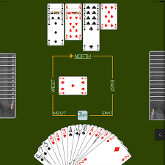

  - Where?
The Bridge Club meet in the main Club area.
When ?
Sessions start at 1.30pm sharp (come early) on a Tuesday afternoon during the winter months.
The sessions stop sometime between 4 to 4-30pm.
There is no formal booking system, just come along.
How much?
A session currently costs £2 per person, and this includes tea and biscuits.
Who?
All Canterbury Bowling Club members are eligible to play. Non-CBC members wishing to play bridge should join as Social members.
Absolute beginners are welcome, but it is recommended that they come and watch for the first session if they are joining mid-season. At the start of the season tutoring is available and it can be available for those who join mid-season, but it is best to contact Jill Jenkins at jillcjenkins@talktalk.net to find out whether a tutor is available on a specific date.
Other things
The play is normal contract bridge (not duplicate) and the convention used is ACOL.
Come as a single or with a partner. All are welcome.
If there any other queries, ask Jill.

Bridge is probably the world’s most widely played card game. If you have never tried it, you don’t know what you are missing!

